

**HOSPITAL MANAGEMENT SYSTEM**

**Participants: Hani Raza ( 16k-3803 )**

**Mehdi Raza (16k-3904)**

**Mustafa Irfan (16k-3886)**

**Batch: Spring 2017**

**Section: “C”**

**Course Name: Computer Programming**

**Course code: CS-103**

**Teacher: FAIZA SATTAR**

**TABLE OF CONTENT**

**Page Content**

**3 - Abstract**

**4 - Motivation/Scope**

**5 - Functionalities**

**6- Concept of OOP**

**7- Class Diagram**

**Abstract:**

Our project that is “Hospital management System” performs all the major tasks present in any hospital. The program is unique in a sense that it is programmed so that it can be used by all manager,doctor and patient to view their appropriate fields. It has an manager with unique id and password to login into the program. Then the program allows to take the information of patient (name, age, address, blood group, gender, phone Number, disease etc ). The option to select disease is done by showing different diseases with their respective doctor and fees. It then saves all the date into file. It can also view patient from the file. There are 3 different types of patient that is check up patient, admit patient, surgery patient. It calculates the fees of patient according to the disease and patient type . It also has the ward so the admit patient bill is further improvised by calculating days he/she spent in hospital. It then adds the fees of ward according to rooms after calculating them into the patient bill. It also calculates the doctor salary after adding fix salary plus per patient bonus. Moreover there is also field for separate service patient who doesn’t use doctor but other services like blood test, x-ray, stool test etc.

**Motivation:**

The idea to program a “Hospital management System” motivated me in a sense that nowadays many small clinics and few hospitals are still working manually on papers to record data and calculate bills. It is also difficult to maintain the data of so many patients and even once gathered so finding it. Moreover remembering the rates of so many doctors with their names and specialization is a difficult task too. Apart from this calculation patient bill manually according to service availed and doctor is also ha hectic job are there are always room for errors. Furthermore calculating doctors salary according to net pay and patients attended is also a difficult task as different patient visits and get treatment from different doctors. Hence me and my group members decided to create a system for hospitals which can do all this work using our program and make their life easy resulting in less errors and a good maintaining of records.

**Scope:**

Our program can be easily used for any hospital as it has all the compulsory functions needed. It can even be used in small clinics which have a single doctor as it helps to manage data for a large number of patients easily and can easily calculate their bill. The program can also act as a database for any big hospital which have thousands of patients on daily basis.

**Functionalities:**

* Choice Selection for manager, patient, doctor.
* Manager Verification
* Add Check Up Patient to the database file.
* Add Emergency Patient to the database file.
* Add Service Patient to the database file.
* Add Surgery Patient to the database file.
* View Check Up Patients from the database file.
* View Emergency Patients from the database file.
* View Service Patients from the database file.
* View Surgery Patients from the database file.
* Viewing list of Diseases with its appropriate doctor and its different fees for checkup Or Surgery from the file.
* Chance of re-entering choice if it is not a valid one.
* Setting doctor according to disease to the file in patient record.
* Viewing different services to the patient if he/she is of service patient kind.
* Calculating bill according to service selected.
* Calculating doctors salary by the calculation of net pay, patients checked and operated.
* Viewing of the patients bill
* Viewing of the doctors bill
* Options to return to previous field whenever needed.
* Option of ending the program to the manager.

**Concepts of Object Oriented Proramming(OOP):**

* **Encapsulation**(Excessed private member through public member functions)  
  **-**Used in all classes
* **Abstraction**(different header files or .h files)
* **Inheritance**  
  -Patient, doctor and manager is inherited from person.  
  **-**Admit, checkup, Emergency and Service patient is inherited from patient.
* **Composition**Admit patient is composed of dates(admit and discharge).
* **POLYMORIPHISM:**

**1) Operator Overloading  
-**It is done in Admit, Emergency, CheckUp and Service Patient(insertion and exertion).

1. **Template  
   -**It is used in Manager class function that is printBill().

* **Vectors  
  -**It is used in admit and checkup patient in the function awardCheckUp() and awardAdmit().
* **Overloaded constructor**-Used in date class.

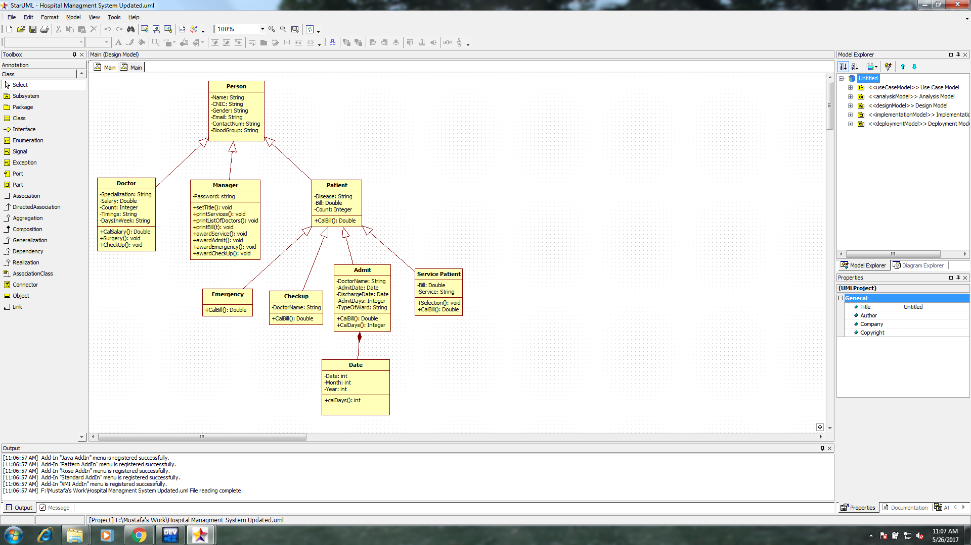 **Class Diagram:**